**4X**

**NV**

**adapter**

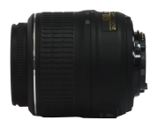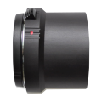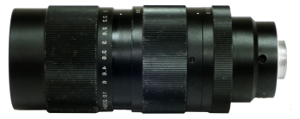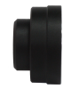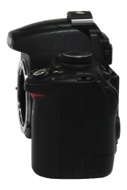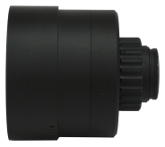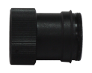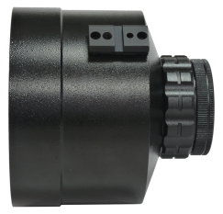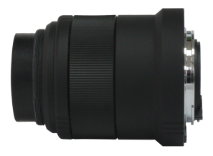

**8X**

**NV-208M**

**NIKON**

**DSLR**

**NIKON Lens**

**NIKON adapter**

**1X**

**CCTV C-mount**

**20X Zoom**

**C-mount**

**adapter**

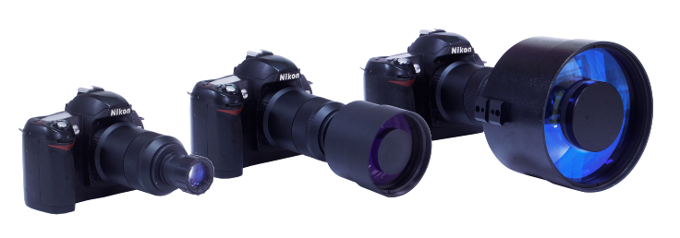

**+25mm F1.17 lens**

**+216.4mm F2 lens (option)**

**+100mm F1.5 lens**

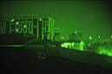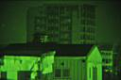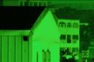

**25mm**

**100mm**

**216.4mm**

***Night Vision Module Adapter***

***for NIKON DSLR***

* The highest performance model for night vision photograph.
* The cutting edge NV-208M incorporates a Gen 2+ tube and combine with catadioptric telescopic lens with super-large aperture openings to convert day-time camera into high resolution image under darkest condition.
* NV-208M comes with 1x and 4x lens and provide 8x lens as option.
* If restrain your camera at ISO 800 and 1/125sec in complete darkness, NV-208M will execute a low light capability to capture a sharp and bright night-time images that can be photographed or video recorded.
* Ideal for wide area surveillance and long distance detection with the configuration of 100mm/216.4mm telephoto catadioptric lens with minimized F-number at 1.5/2 only.
* Permit to use with our IR laser Illuminator to extend the range of 500m while retaining the function of photographing, recording and image stabilization.

**Option:**

1. **216.4mm, F2**

**lens**

1. **IR illuminator**

**(500m range)**

|  |  |  |
| --- | --- | --- |
| **Model** | | **NV-208M** |
| **NV adapter** | Length | 98.5 mm |
| Diameter | 66.1 mm |
| Weight | Around 342g |
| Bayonet mounts | AF-S to Nikon |
| Mount to objection lens |
| Power | From Camera |
| **Image intensifier tube** | Photocathode operating diameter | 18 mm |
| Photocathode type | S-25 |
| Resolution | 57-64 Lp/mm |
| Sensitivity | 600-750 µA/lm |
| Luminous gain | 40,000 fl/fc at 10-6 fcd |
| Dark background brightness, max | 1,5x10-3 cd/m2 |
| Signal-to-noise ratio | 20-23 |
| Current consumption, max | 16mA |
| Mean time before failure | 10,000 hours |

**Objective Lens**

|  |  |  |  |
| --- | --- | --- | --- |
| **Magnification** | 1x | 4x | 8x |
| **Optics** | Refractor | Catadioptric | Catadioptric |
| **Angle** | 40° | 10° | 5° |
| **Focal length** | 25mm (≈75mm/135) | 100mm (≈300mm/135) | 216.4mm (≈600mm/135) |
| **Aperture** | f 1.17 | f 1.5 | f 2 |
| **Outer dia..** | 3.5cm | 8cm | 13cm |

**Standard package**

***RAYSUN NV-208M***

**(1) NV-208M main unit**

**(2) 25mm, F1.17 lens**

**(3) 100mm, F1.5 lens**

**(4) IR illuminator adapter**

**(5) Watertight case**

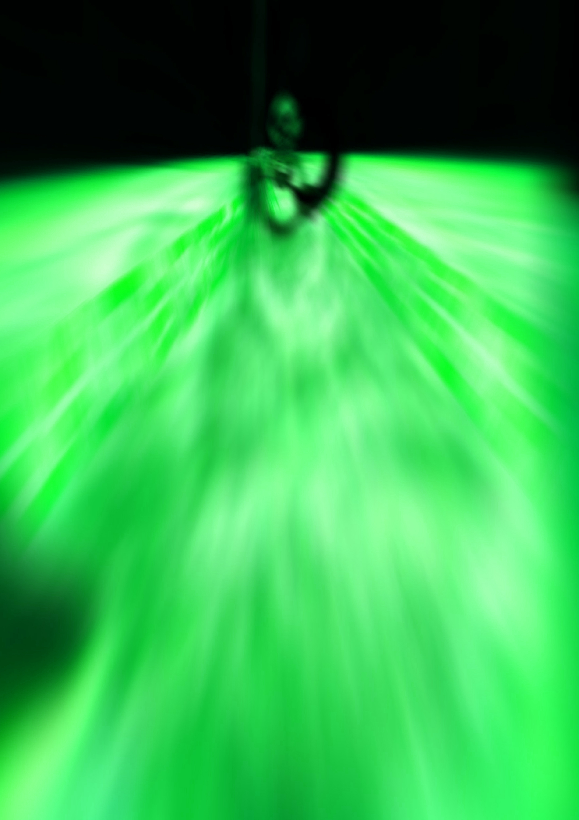

**Specification：**

**Performance：**